**PYTHON CLASS – 4**

1. Write a Program to print new list which contains all the first Characters of strings present in a

list

LIST_STATES = ["GOA","RAJASTHAN","KARNATAKA","GUJRAT","MANIPUR", ‘MADHYA PRADESH’]

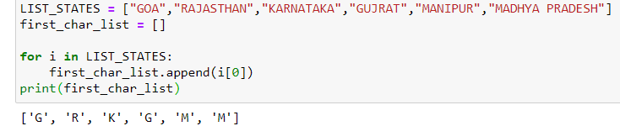

2. Write a program to replace each string with an integer value in a given list of strings. The replacement integer value should be a sum of AScci values of each character of type corresponding string.

LIST: ['GAnga', 'Tapti', 'Kaveri', 'Yamuna', 'Narmada' ]

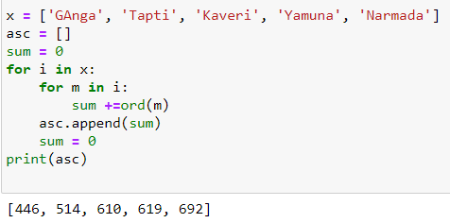

3. ###### You have to run your Program at 9:00am. Date: 14th April 2020.

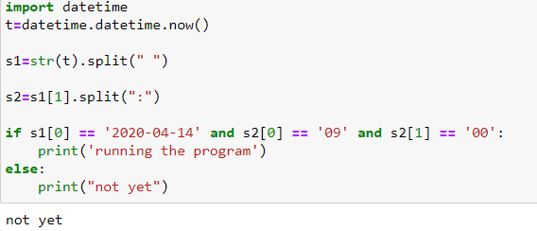

4. Give a tuple: tuple = ('a','l','g','o','r','i','t','h','m')

1. Using the concept of slicing, print the whole tuple
2. delete the element at the 3rd Index, print the tuple.

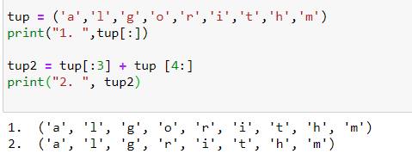

5. Take a list REGex=[1,2,3,4,5,6,7,8,9,0,77,44,15,33,65,89,12]

- print only those numbers greater than 20

- then print those numbers those are less than 10 or equal to 10

- store these above two list in two different list.

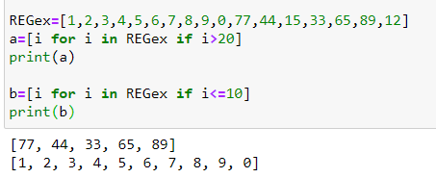

6. Execute standard LINUX Commands using Python Programming

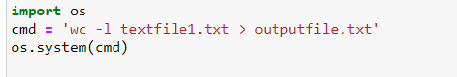

7. Revise *args and **kwargs Concepts

